As it is written, there is none righteous, not even one.
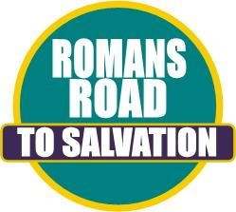

Romans 3:10
For all have sinned and fall short of the glory of God.

Romans 3:23
But God demonstrates His own love toward us, in that while we were yet sinners, Christ died for us.

Romans 5:8
For the wages of sin is death, but the free gift of God is eternal life through Christ Jesus our Lord.

Romans 6:23
If you confess with your mouth Jesus as Lord, and believe in your heart that God raised Him from the dead, you will be saved; for with the heart a person believes, resulting in
righteousness, and with the mouth he confesses, resulting in salvation.

Romans 10:9-10
Whosoever calls upon the name of the Lord shall be saved.

